|  |
| --- |
| Completed By: Click here to enter text. |
| Approved By: Click here to enter text. |
| Department: Click here to enter text. |
| Issue Date: Click here to enter text. |
| Updated date: Click here to enter text. |

Click here to enter text.

Add Hazardous Class Description if Needed

Approval/Training(s) Required

Click here to enter text.

Chemical Properties & Hazards

**Chemical Properties**

Click here to enter text.

**Hazardss**

Click here to enter text.

Personal Protective Equipment

Click here to enter text.

Engineering Controls

Click here to enter text.

Handling & Storage

**Handling**

Click here to enter text.

**Storage**

Click here to enter text.

First Aid & Spills

**First Aid**

Click here to enter text.

**Spill**

Click here to enter text.

Disposal

Click here to enter text.

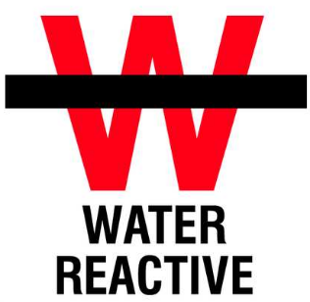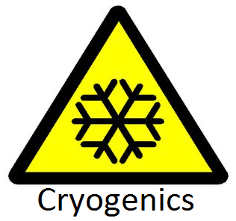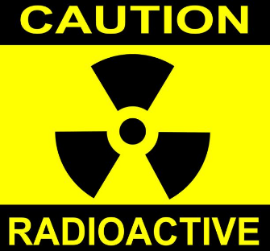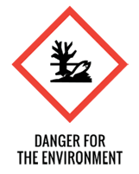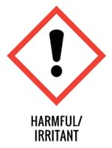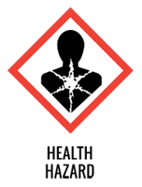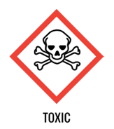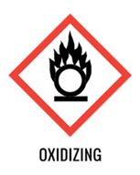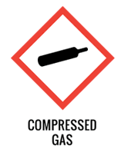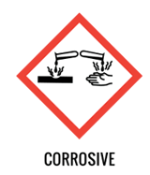

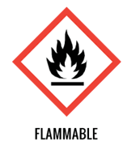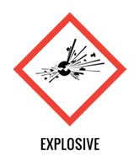





Safety Glasses



Cryogenic Gloves



Splash Goggles



Ear Protection



Face Shield Required



Lab Coat



Protection Suit

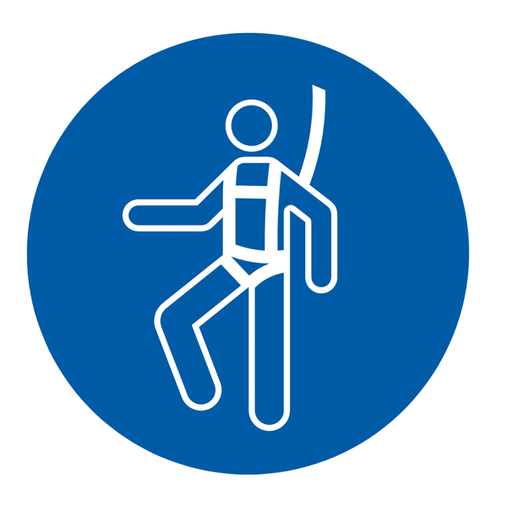

Fall Protection Harness



High Vis Vest

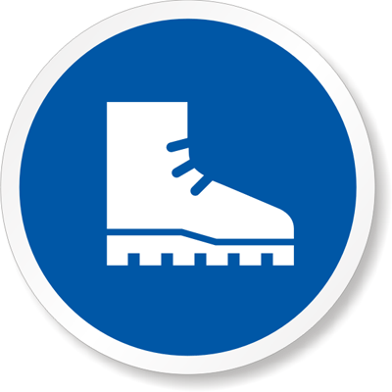

Safety Shoes



Latex Gloves



Dust Mask

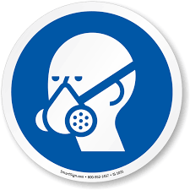

Respirator



Hard Hat



Face Shield